C:\Documents and Settings\Administrator\Local Settings\Temporary Internet Files\Content.IE5\LRY3DNVK\MCj04119480000[1].wmfC:\Documents and Settings\Administrator\Local Settings\Temporary Internet Files\Content.IE5\LRY3DNVK\MCj04119480000[1].wmf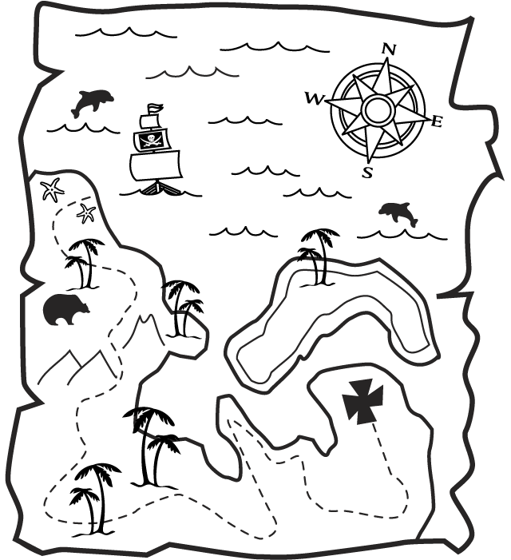C:\Documents and Settings\Administrator\Local Settings\Temporary Internet Files\Content.IE5\4B7Z8FH1\MCj03503550000[1].wmfC:\Documents and Settings\Administrator\Local Settings\Temporary Internet Files\Content.IE5\4B7Z8FH1\MCj03503550000[1].wmfC:\Documents and Settings\Administrator\Local Settings\Temporary Internet Files\Content.IE5\4B7Z8FH1\MCj03503550000[1].wmfC:\Documents and Settings\Administrator\Local Settings\Temporary Internet Files\Content.IE5\LRY3DNVK\MCj04119480000[1].wmfC:\Documents and Settings\Administrator\Local Settings\Temporary Internet Files\Content.IE5\LRY3DNVK\MCj04119480000[1].wmf

Swamps of Terror

Hangman’s Tree

Cave of Hell

World’s End Waterfall

Mountains of Doom

Shipwreck Cove

Dead Man’s Chest

Davy Jones’s Locker

Jungle of Death

Black Pearl

Pirates Cove

Snake Swamp

Skull Rock

Lands End